Work Assignment - 1
Course Code: CSE-2340
Course Title: Software Development I

Question 1:
Problem 1: Secret Message Reversal (Java Only)

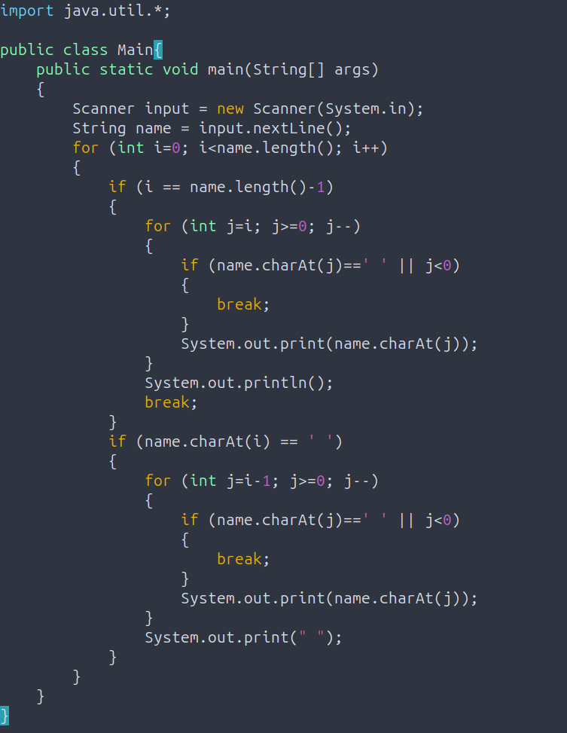

Problem 2: Unique Jersey Numbers (Java Only)

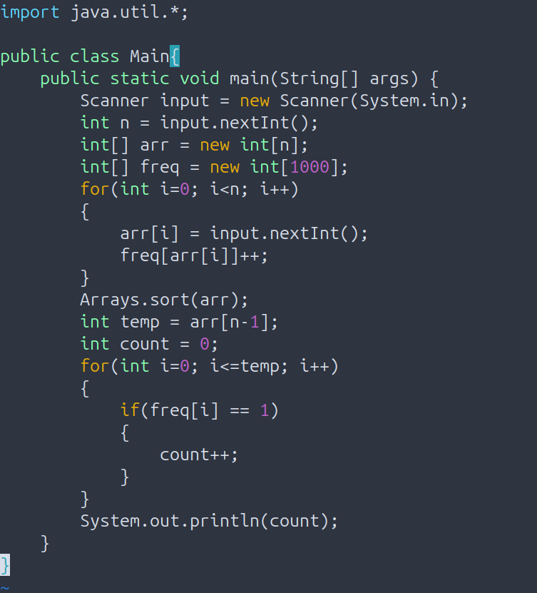

Question 2:
Answer to SQL Question 1:

The four basic operations of SQL known as CRUD are Create, Read, Update and Delete. They are explained briefly below:
1. Create: Uses the keyword ‘INSERT’ to add new information into a table. This is how the data enters an existing database.
2. Read: Uses the keyword ‘SELECT’ to collect and view data from the table. It is essential for displaying data to user.
3. Update: Uses the keyword ‘UPDATE’ to change existing information in the table. It is used for modifying table data from one or more rows.
4. Delete: Uses the keyword ‘DELETE’ to remove information from database. This permanently deletes records from database.

An example for each operation is written below
CREATE:

INSERT INTO Employees(EmployeeID, Name, Age, Department) VALUES(“C243007”, “Rahat”, “20”, “Development”);

READ:

SELECT * FROM Employees;

UPDATE:

UPDATE Employees SET Department = “Tester” WHERE EmployeeID = “C243007”;

DELETE:

DELETE FROM Employees WHERE EmployeeID = “C243007”;

Role of ‘WHERE’ clause in UPDATE and DELETE:
The keyword ‘WHERE’ is used to find data row using their value. This helps us to update and delete information from database using values.

What if we forget to use ‘WHERE’?
If we forget to use ‘WHERE’ while updating or deleting, we’ll face some major issues.
While updating, we would write
UPDATE Employees SET Department = “HR”;
which will change the Department for the entire database.

While deleting, we would write
DELETE FROM Employees;
which will erase the whole database.

SQL Question 2:
1: Insert a new student named Farhan(StudentID=6, AGE=21, Department=EEE, Marks=80)

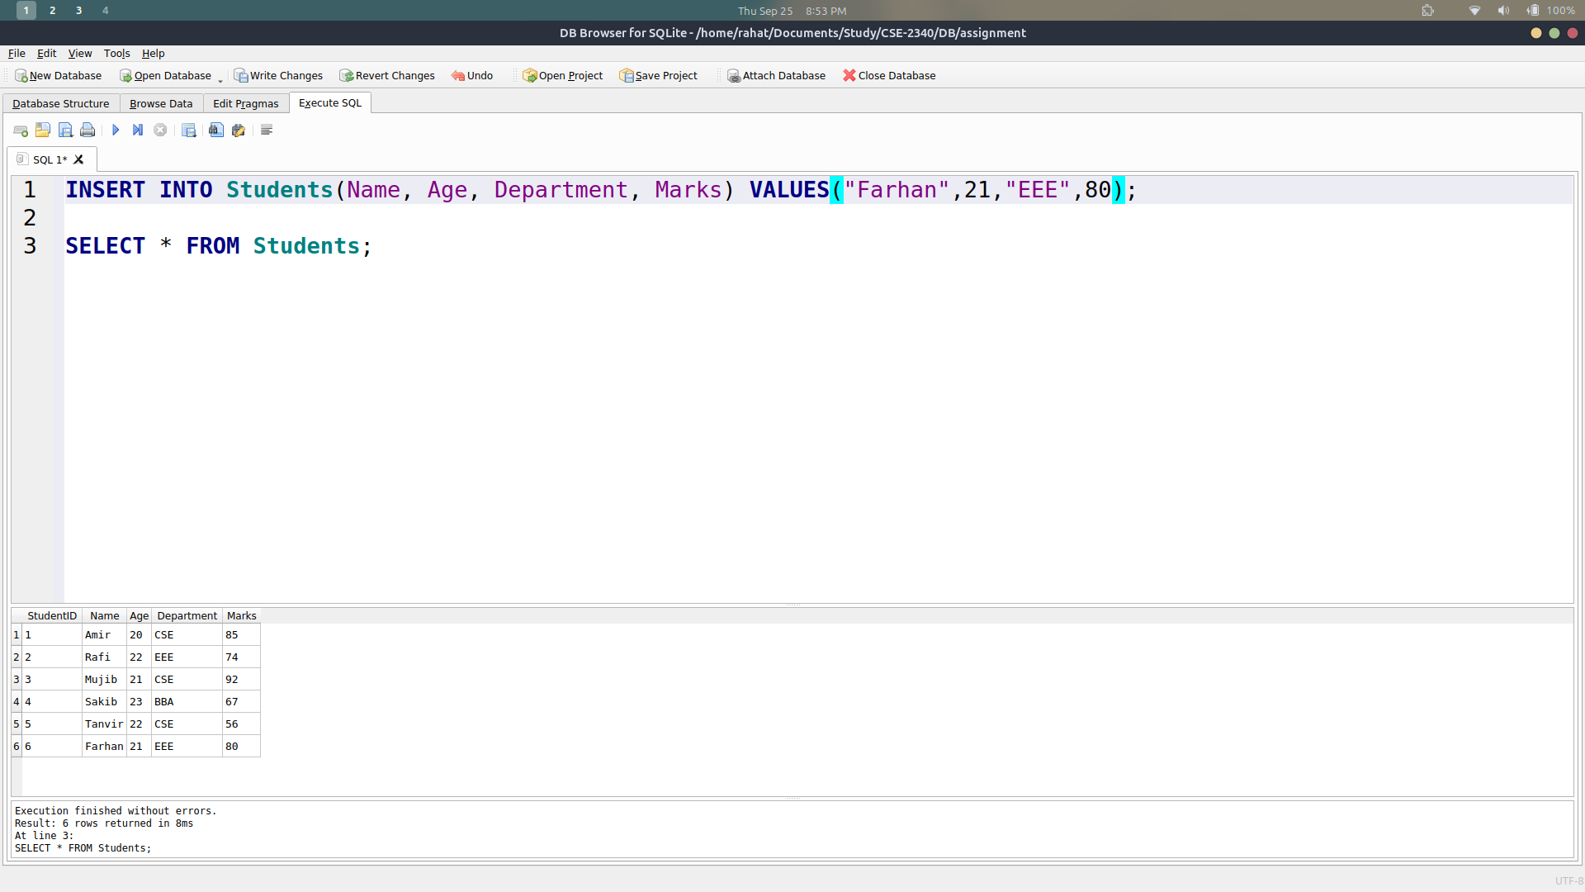

2. Select all students from the CSE department who scored more than 70 marks.

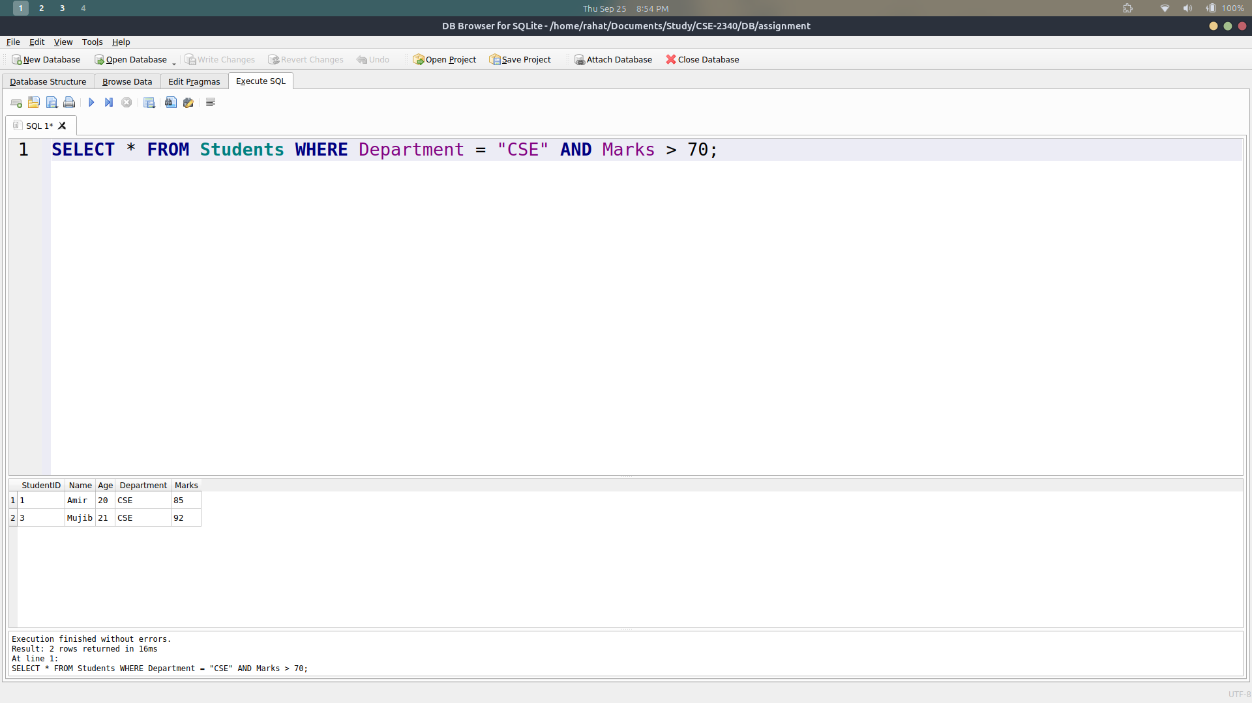

3. Update the marks of Tanvir to 65.

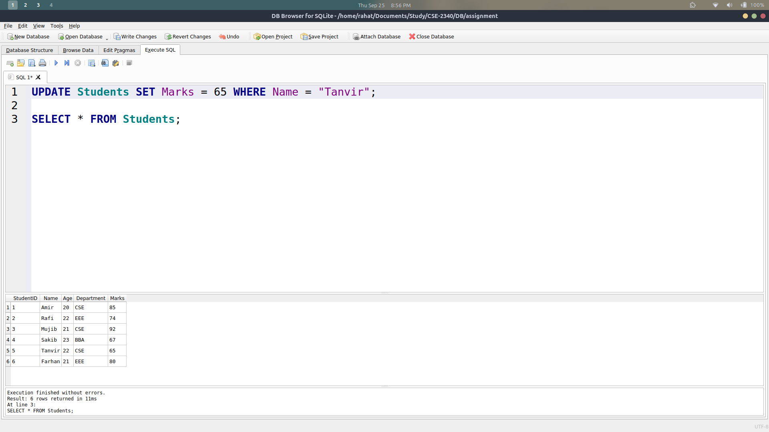

4. Delete all students whose marks are less than 60.

